New Crash Report Code Set Changes
Beginning March 1, 2014, changes will be implemented to the codes sets in the Motor Vehicle Crash Report. The most significant changes are documented below including detail about the values. More detailed information on these and other changes will be available on our webpage at http://publicsafety.utah.gov/highwaysafety/crashcitation.html
Sequence of Events
Added: #32 – Collision between motor vehicle in transport and vehicle cargo/part or object set in motion by motor vehicle
This code can be used in the Sequence of Events, First Harmful Event, and Most Harmful Event to denote a collision between a motor vehicle and cargo from another motor vehicle or a part of another motor vehicle. This code would also be used to denote a collision between a motor vehicle and an object that was set in motion by another motor vehicle (i.e. a tire tread or other debris that was flipped up by a motor vehicle that struck another motor vehicle)
Deleted: #00 – No Damage or Injury, This Vehicle
This code is being removed because its use is not valid in the sequence of events. If a vehicle has not been involved in a collision or had not sustained damage or had occupants that received any injury the vehicle would not be included on the crash report form.

Manner of Collision
Added: #97 – Other*
This code is used for any collision between two motor vehicles in-transport where the collision is not described by the other attributes. Examples would include:
- an airborne vehicle makes contact with its front or undercarriage to the other vehicles' hood or top

Area of Initial Impact
Added: #17 – Cargo Loss
This code is used to specify impact was not made to an involved motor vehicle but rather to the cargo of that motor vehicle. (i.e. A vehicle loses an appliance from a trailer. The vehicle was not impacted but cargo from that vehicle was damaged)

Location of First Harmful Event
Added: #09 – Parking lot aisle or stall (see diagram A)
This code was added to better identify event locations to correspond with federal crash guideline standards. Parking lot stalls applies only to actual designated stalls. Parking lot aisles are vehicle travel ways primarily used for accessing parking lot stalls.
Added: #10 – Quasi-public road or parking lot way (see diagram A)
This code was added to better identify event locations to correspond with federal crash guideline standards. Quasi-public road or parking lot way has the same definition as found in Utah Code section 41-6a-214.
Change: #06 – In parking lane or zone (within trafficway)
This code set was renamed to include “within trafficway” to better clarify the location description. With the addition of codes 09 and 10, this code was be solely used to identify parking areas on or adjacent to roadways.
Change: #08 – Outside Trafficway (see diagram B)
This code set was renamed from “outside right-of-way” to “outside trafficway.” The element is the same but with a better name description. Trafficway has the same definition as “highway” in the state code. This code would apply when the first harmful event occurred outside the trafficway but not in codes 09 or 10 noted above.

Roadway Description
Added: #06 – Parking lot aisle or stall
See element description under Location of Harmful Event above.
Added: #07 – Quasi-public road or parking lot way
See element description under Location of Harmful Event above.

DIAGRAM A
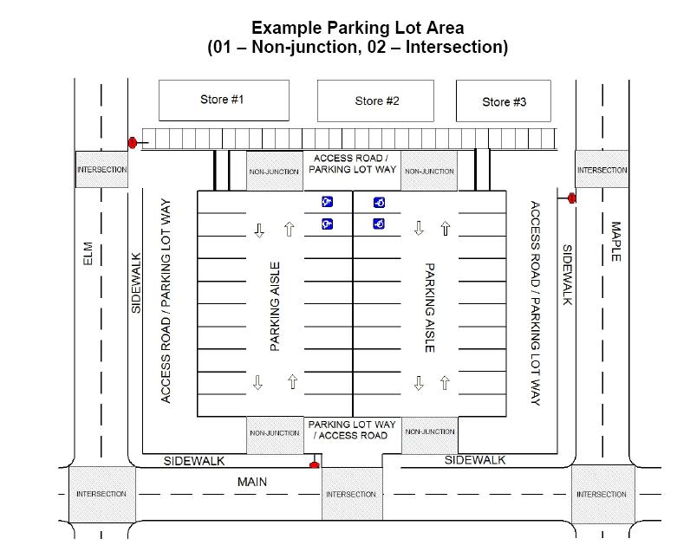 DIAGRAM B
ANSI D16.1- 2007
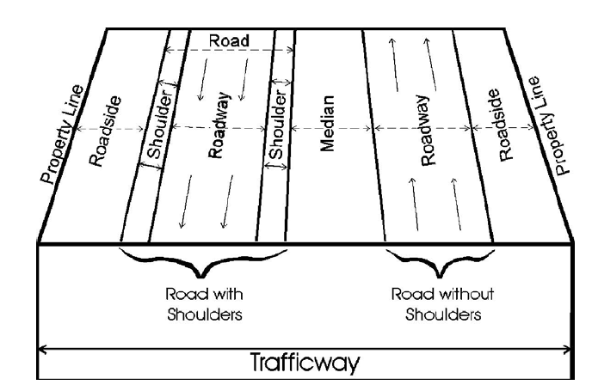
ANSI D16.1-2007

