Download: Living Proof Video

Zero Fatalities released a new video today, “Living Proof.” This 60-second video can be downloaded with the links below. We encourage everyone to share this important message. The video can also be viewed at ZeroFatalities.com and on the program’s corresponding YouTube Channel.

The Barney family spoke at today’s event and is the first group in the video.

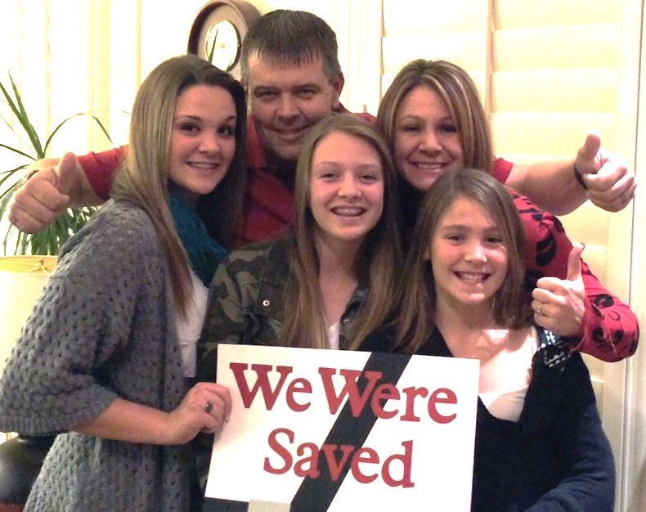
MOV
https://nomad.office.ppbh.com/fbsharing/8OLFynTT
WMV
https://nomad.office.ppbh.com/fbsharing/YdutoaBy

*Upon request, 15 and 30 second spots of the video can be made available.

